S3 – GROUP BY - AVG -SUM

# What you will know:

GROUP BY – AVG - SUM

# Instructions: Open [this online SQL editor](https://www.w3schools.com/sql/trysql.asp?filename=trysql_op_in)

**Exercise 1: Databases on W3school**

Each product of **Products** table has a **category ID** (*this ID refers to an element in the* ***Categories*** *table*)

## Q1 : Write a SQL query to display the **number of products per category**.

Expected columns:

CategoryID Number of items

**Your query:**

SELECT CategoryID,count(ProductID) as “Number Of Product” FROM Products group by(CategoryID); …………………………………………………………………………………………………………………………………………………………….

## Q2: Write a SQL query to display the **average price** of items per category ID.

Expected columns:

CategoryID Average items price

**Your query:**

SELECT CategoryID, avg(Price) FROM Products group by (CategoryID); …………………………………………………………………………………………………………………………………………………………….

## Q3: Write a SQL query to display the **total of the price** of all items per category ID.

Expected columns:

Category ID Total items price

**Your query:**

SELECT CategoryID, sum (Price) FROM Products group by(CategoryID);

**Exercise 2: World Table**

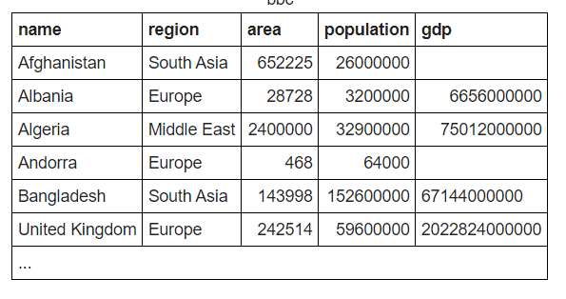

**Q1:** write a statement to sum of population of all countries.

**Your query:** SELECT sum (population) FROM World;

**Q2** : write a statement to sum of population of all countries in « South Asia »

**Your query**: SELECT name, sum (population) FROM World where region = “South Asia”;

**Q3:** write a statement to count GDP is null

**Your query:** SELECT count (gdp) FROM World where gdp is null;

**Q4**: Write a statemet to showthe number of countries in each continent and group by continents:

**Your query:** SELECT count (name) FROM World group by (region);

**Q5** : write a statement to show the total population in each continent, group by continents :

**Your query:** SELECT sum (population) FROM World group by (region);

**Q6 :** For each relevant continent show the number of countries that has a population of at least 200000000.

**Your query**: SELECT count (name) from World where population=>200000000;

Top of Form